How to provide school boards with information about learning outcomes; one of the most important aspects of the quality of education in their schools? A new development in Cito’s Monitoring and Evaluation System for primary education

38th IAEA Annual Conference
Astana, September 17-21, 2012

Jasmijn Oude Oosterik
Cito, Arnhem, The Netherlands

- Introduction

In the Netherlands, schools are held more and more responsible for the quality of (their) education. They have to implement an active policy of quality control on both student and school level. Cito’s Monitoring and Evaluation System for primary and secondary education (and recently also for children with special needs) provides schools with valuable additional information about the quality of education on both levels.

Recently, Cito’s Monitoring and Evaluation System for primary education in the Netherlands has been expanded. It is now possible to report on school board level, besides reporting on student and school level. The latter module of the system has been developed in close collaboration with school boards, to enable them to monitor the quality of education of their schools. With this last module, Cito’s Monitoring and Evaluation System for primary education can be used to provide information on learning outcomes to all stakeholders, the individual pupil, the grade/cohort, the school and one step higher: the school board.

In this paper, a brief overview of Cito’s Monitoring and Evaluation System for primary education will be given. We will first describe how test data can be transformed into information on learning outcomes and progress at different levels (pupil, grade/cohort and school). And then special attention will be given to the reports for school boards.

- A short outline of Cito’s Monitoring and Evaluation System for primary education

The Monitoring and Evaluation System for primary education, developed by Cito from 1986 onwards, is a practical tool for monitoring learning outcomes. It consists of a coherent set of nationally standardized tests (paper based and computer based) for longitudinal assessment of a pupil achievement throughout primary education. Integrated in the system is a computer program, which generates extensive and advanced reports of the progress of (groups of) pupils.
The monitoring system contains not just tests for measuring sub-skills of language and mathematics, but also tests for social-emotional development and study skills.

During the primary school period pupils are usually tested usually twice a year: half way the school year and at the end of the school year. The results of the successive assessments are converted to the same fixed scale, enabling schools and teachers to monitor the progress of pupils over a number of years. This possibility is offered by a measuring technique based on item response theory. For more information about the item response theory the reader is referred to Attachment 1.
The continuity in the collection of data is of great importance for early identification of learning problems. In this way Cito’s Monitoring and Evaluation System complements the impression that teachers have of their pupils on the basis of day-to-day assessment. Moreover, the nationally standardized tests of the system make it possible to widen one’s view beyond the classroom and the school: results of pupils can be compared nationally with those of other pupils.

Working with the system does not merely involve testing and registration of test results. It is an educational system that allows teachers to make decisions about the progress of the learning process in each subject on the basis of the data collected. Should the data indicate that the pupil is not performing well, further analyses have to be done and, where needed, appropriate remedial actions will have to be taken. Therefore the system has been set up as a procedure that calls for a systematic, cyclic approach.

In the systematic approach three stages can be distinguished:
- Identification
This implies all the activities that have to do with recording the pupil’s achievements and interpreting the results (testing, marking of the tests, registration and preliminary interpretations).
- Analysis
Should the results of the test show that the pupil’s development is not up to standard or stalls, then it is advisable to collect additional data. Firstly, to verify the signal and secondly, to pinpoint specific problems or gaps. The system offers the teacher the equipment to carry out this analysis.
- Actions
On the basis of the information of the former steps a specific plan of remedial actions can be set up, carried out and evaluated. Wherever useful and possible the system provides teachers with additional exercises and directions for remedial measures.

- Reporting at different levels

Cito’s Monitoring and Evaluation System for primary education has various possibilities for reporting that provide help in the monitoring of learning outcomes. Although the primary purpose of Cito’s Monitoring and Evaluation System was to provide information about the position and progress of individual pupils in a number of subjects, nowadays the system is also used to extract information on higher levels of aggregation, such as grade, cohort and school level. In the next section, several reports on different levels are explained.

Reporting at individual level
Figure 2 is an example of a pupil report, a graph in which the pupil’s progress is visible throughout the years. The horizontal axis represents time, while the vertical axis is the scale that represents the ability. The orange line summarizes the test performances of this pupil for six time points, from the mid of grade 3 until the end of grade 5.
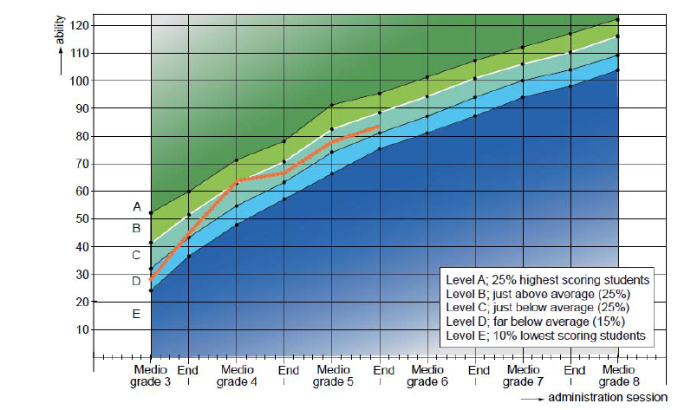
Figure 2: Example of a pupil report

The pupil report does not only show the growth of the ability but also the relative position of the pupil among their peers. The data collected from the various subpopulations in a national survey are used as a frame of reference. In the graph four curves have been drawn that correspond to percentiles 10, 25, 75 and the population mean. On the basis of these data five levels can be distinguished:
Level A (dark green coloured area): 25% highest scoring pupils
Level B (light green coloured area): just above average (25%)
Level C (turquoise coloured area): just below average (25%)
Level D (light blue coloured area): far below average (15%)
Level E (dark blue coloured area): 10% lowest scoring pupils
The orange line shows that the pupil started out below average (as a level D pupil) and performs below average (as a level C pupil) for all successive time points although there is a relative improvement at the mid of grade 4 (see medio grade 4 were the mean is reached). From the end of Grade 4 onwards this pupil progresses as one could expect from a level C pupil.

Reporting at grade level
Figure 3 is an example of a group report which graphically shows the results of all pupils from one grade. At a glance a teacher can conclude which of the pupils’ scores are below or above average compared with the results of other pupils nationwide. Next to the ability scores of the individual pupils, the average ability score of the group as a whole is also included in this group report. The data collected from the various groups in the national survey are used as a frame of reference to compare the relative position of this specific group to other groups of pupils.
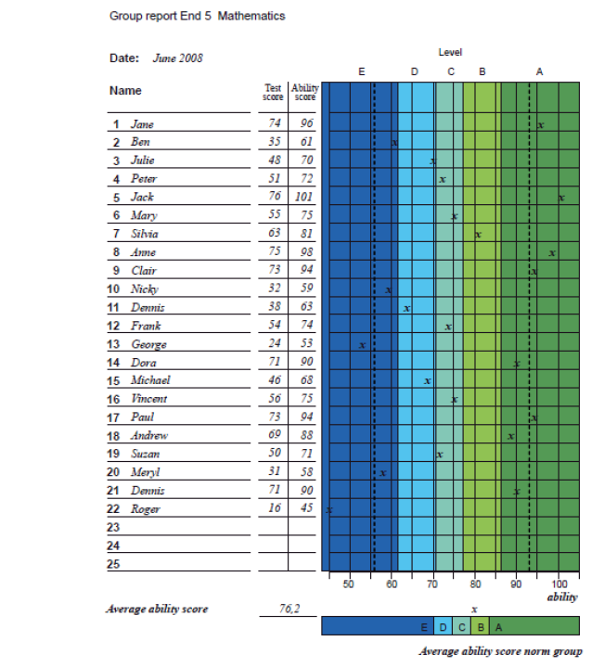
Figure 3: Example of a group report
Reporting at School level
When Cito’s Monitoring and Evaluation System has been implemented into the school for a couple of years in several grades, the data gathered can also be used for school self-evaluation purposes. It is possible to fill in some reports manually, but more advanced reports can be made with a separate module of the computer program specially designed for this function. The module generates cross-section reports and trend analysis for various subjects.

Cross-section reports
A cross section shows the distribution of pupils of different grades across the five levels (A to E) for one or several curriculum areas at a certain moment in time. A cross section makes clear how the different grades perform in comparison with the national mean and whether there are grades that deviate from the performance level of the school. See figure 4 for an example.

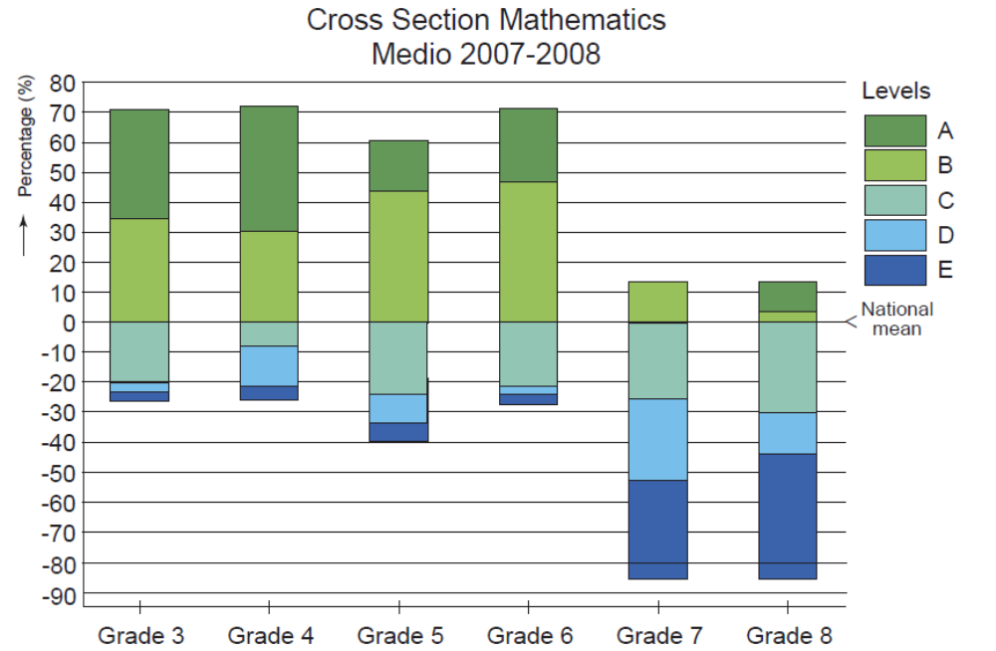

Figure 4: Example of a cross-section for Arithmetic-Mathematics

The 0% line indicates the national mean. Above this line the percentage of pupils in the different grades with a level A or B are depicted. In the national reference group about 50% have an A or B-level. The other 50% have a C, D or E-level. The results of grades 7 and 8 are salient. In the case of grade 7 only 15% of the pupils score above the national mean and there are no A-level pupils. Approximately the same percentage of the pupils of grade 8 score above the national mean (although there are pupils with an A-level), while 85% of the pupils score below the national mean. Compared with the results of the other grades in this school, these results are remarkable.
Of course the system cannot find the reason for these remarkable results, but it points to a possible problematic area and it is up to the school to find a reasonable explanation for such a phenomenon. In the example given, the reason might be that the group of pupils are exceptionally weak or it might be that something is going wrong systematically in grades 7 and 8. If the former explanation is correct, the performance of the same groups of pupils – a cohort – should show below average performance over several years and probably also in other subjects. If the latter explanation is correct, different cohorts within the same school should show below average performance in grades 7 and 8.
To gather more information which makes it able to confirm or reject these hypotheses, the program allows two kinds of trend analysis: cohort based trends and grade based trends (see Attachment 2).

- School board module: reporting to school boards

Recently, a reporting system by and for school boards of primary education has been developed. This reporting system, the school board module, is part of Cito’s Monitoring and Evaluation System for primary education and is integrated with the computer program. It gives school boards insight into the test results of their schools. With these test results the school boards are able to monitor the quality of education in their schools or their groups of schools.

Purpose and function of the school board module
This module is developed to provide school boards with information about the learning outcomes of their schools. With this information school boards can decide whether they need to change their policy to improve education in their schools. The school board module gives insight into the learning outcomes of schools after each test period and also into the progress over time.
An important element in the reports is the signaling function. With this function school boards can compare the learning outcomes of their schools:
- among each other
- with the national mean
- with the quality norms of the Inspectorate
- with the mean of all schools belonging to the school board

The module indicates when the learning outcomes of a school are below the national mean and/or quality norms of the Inspectorate. The results will turn yellow or red. In this way, school boards can see at a glance if the learning outcomes are still sufficient.

The importance of developing the module in collaboration with the target group
The school board module is developed in close collaboration with a number of school boards, to fit in well with their practical demands within the framework of school improvement.
Two years ago, the development started with mapping the needs of five school boards. These five school boards had much interest in standard reports in which they gained more insight in the learning outcomes of their schools.
In the first phase of the development process, design drafts of reporting forms were submitted to the five school boards. These sketches included many tables and graphs. The school boards, however, preferred a compact presentation of reports to see at a glance where problems are likely to occur or where adjustments are needed. Too much detailed information in the reports will not benefit the purpose (signaling). This advice was included in the development of a first version of a web-based prototype.
The second phase of the development process consisted of a pilot in which the first prototype with fictional data was submitted to 15 school boards. This prototype has been evaluated with the school boards and on the basis of this evaluation an improved version of the prototype was developed in which real data (test results) of schools were used.
In the third phase, which is still running, 50 school boards are trying out this version of the school board module. In the autumn of 2012 the first production version will start and every school board in the Netherlands will be able to choose whether or not to implement this module.

The school board module is a web-based application with a rich graphical user interface for use in all major browsers on both Windows computers and Apple Macintosh computers.

Reports in the school board module
After each test period schools governed by a school board, have to submit the test results (anonymized at pupil level) for reporting to Cito. The submission of the anonymous test results is done via a secure Internet connection. The computer program facilities this. The school board module has various possibilities for reporting that provide insight into the learning outcomes of the schools after each test period and the progress over time. In the next section, several reports will be explained.

Figure 7 is an example of the display Monitor, on which school boards can see at a glance if the tests have been taken and the results have been submitted. Each school that submits the test results of the most recent test period, gets a green dot. The green checkmarks show the school board which test results of which tests are send in. If there is no checkmark, no data have been submitted of the corresponding test. A red dot means that the test results of the most recent test period have not been submitted.
By clicking on the magnifying glass icon of a school (yellow arrow), the school board can see in detail which tests per grade were taken and how many pupils have been tested.

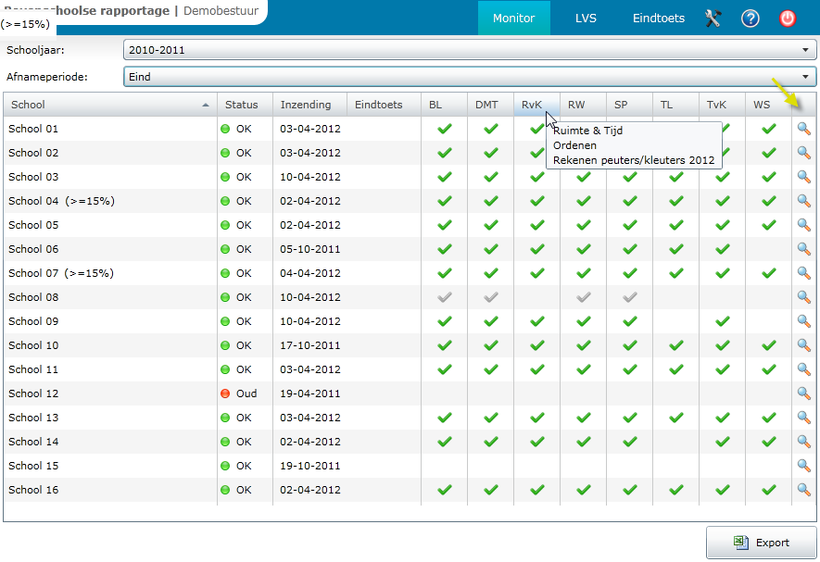
Figure 7: Example of the display Monitor

Figure 8 is an example of a report that gives school boards an overview of the learning outcomes of all schools after a specific test period. In this example results on four test in grade 4 during one school year are displayed. In this overview school boards can compare the average test score (on one or more tests) of a school with the national mean, with the quality norms of the Inspectorate or with the mean of all schools belonging to the school board.
In the report in figure 8, the learning outcomes of the schools are also compared with the national mean and the quality norms of the Inspectorate, which are indicated in blue and italic.
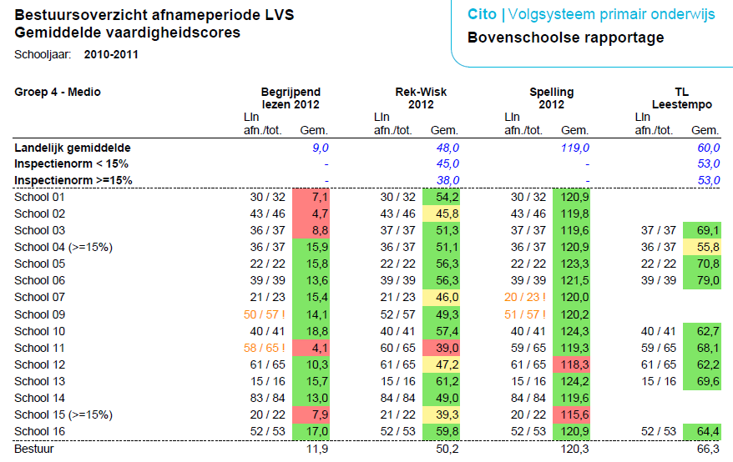

Figure 8: Example of the report School board overview of testing period

In the report of figure 8 multiple signaling functions can be distinguished:

- Green means that the average test result is well above the national mean as the quality norms of the Inspectorate.
- Red means that the average test result is well below the national mean as the quality norms of the Inspectorate.
- Yellow means that the average test result is between the national mean and the quality norms of the Inspectorate.
- In addition, if the number of pupils that took the test is insufficient, it colors orange and an exclamation mark appears. See for example the first test (comprehensive reading) at school 9 and 11 and at the third test (spelling) at school 7 and 9. A consequence of too little or no test results may be that empty spaces occur. See for example the last test at school 1, 2, 7, 9, 14 and 15.

Figure 9 is an example of a report that gives school boards an overview of the progress of all its schools on a particular test in time. In this example the results on the test comprehensive reading in grade 4 during three school years are displayed. The distribution of test results over the levels A to E is shown per school and per test. These results can be compared with the national distribution over the levels A to E and with the mean of all schools belonging to a school board. In the report in figure 9, the learning outcomes of the schools are compared with the national distribution over the levels A to E, which are indicated in blue.
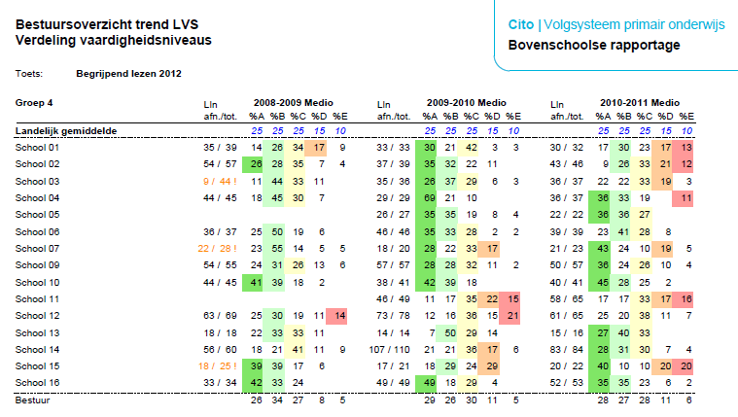
Figure 9: Example of the report School board trend overview

Also in the report of figure 9 different colors can be observed:

- Green means that the school has more than 25% of the pupils in level A compared with the national mean.
- Light green means that the school has more than 25% of the pupils in level B compared with the national mean.
- Yellow means that the school has more than 25% of the pupils in level C compared with the national mean.
- Orange means that the school has more than 15% of the pupils in level D compared with the national mean.
- Red means that the school has more than 10% of the pupils in level E compared with the national mean.

In conclusion, Cito’s Monitoring and Evaluation System is a practical tool for teachers and schools to systematically monitor the quality of education. The monitoring system can be used to provide information on learning outcomes to all stakeholders: the individual pupil, the grade/cohort, the school and the school board.
It has been of great importance to develop the school board module in close collaboration with school boards. By doing so, the module fits well with their practical demands in monitoring the quality of education.
Although the examples of reports in this paper are related to primary education, the Monitoring and Evaluation System also applies to secondary and basic education. In the Netherlands, Cito has developed such a system for secondary education too.
References

Lubbe, M. van der (2009). The use of the Cito Monitoring and Evaluation System for school self-improvement in The Netherlands. Paper presented at the 35th IAEA Annual Conference, Brisbane, Australia.

Moelands, H. (2010). Computerized adaptive testing in the Monitoring and Evaluation System for primary education in The Netherlands. Paper presented at 36th IAEA Annual Conference, Bangkok, Thailand.
Attachment 1
Item Response Theory as a measuring technique

For a monitoring system it is desirable that it aimed at monitoring pupils’ achievement over a number of years, that the various tests of a subject matter measure the same abilities and that the results can be put on the same fixed scale. Only then it can be determined to what extent a pupil has made progress compared with previous measurements. This possibility is offered by a measuring technique based on item response theory (IRT). IRT presents a general framework for constructing measuring instruments, validating measurements, estimating item and test characteristics, estimating individuals’ abilities and spread of abilities in (sub)populations and it provides a framework for interpreting test results. In the IRT model used in Cito’s Monitoring and Evaluation Systems, the chance that an item can be solved is specified as a function of a latent one-dimensional pupil ability and one or more item characteristic (e.g. difficulty). The difficulty of the items and the latent ability can be represented with the help of the estimated item characteristics. This is done with the help of OPLM, a computer program developed by Cito based on a One Parameter Logistic Model.

Particularly the fact that both pupil abilities and item characteristics can be put on the same scale and can be related to each other is of great advantage to a Monitoring and Evaluation system:
- The results on tests that differ according to difficulty, contents and number of items can be compared. In other words: a pupil’s (for example say Thomas) results on the math tests of the mid of grade 4 can be depicted on the same scale as the results he obtained six months before on the math test of the end of grade 3, so that the degree of progress can be determined. Furthermore, the position that the pupil takes on the scale can be compared with that of other pupils nationally.
- On the basis of the position on the scale a general conclusion can be drawn about the degree of mastery of a particular subject matter.

Figure 1 gives an example of a scale consisting of several types of math items and the ability estimate of a pupil (Thomas) on the basis of the test results on arithmetic tests that have been taken at six months’ interval (June ’11, Jan ’12, June ’11) half way the school year and at the end of the school year. Thomas’ position on the scale (June ’11, end grade 3) indicates that he has mastered the type of items that is below his ability level (e.g. 11 + 7 = ), but that the items that are above his ability level are still too difficult for him. Items that are on the same level are partially mastered. Six month later his ability has increased (Jan ’12, mid grade 4). Now he has mastered items that were too difficult at an earlier moment (e.g. counting backwards).

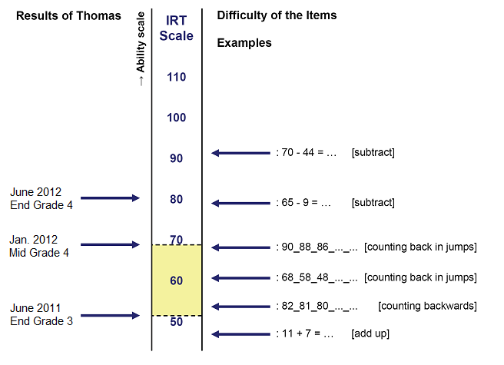

Figure 1: Part of the scale for Arithmetic

If, at the same time, for every measuring moment the spread of a (national) reference group is indicated on the scale, the relative position of the pupil compared with his ‘peers’ can be determined.

Thus, we see that this technique allows three kinds of interpretations of the results:
- Self-referenced
The degree of progress can be determined in relation to an earlier moment in time. After each measurement the raw score of a test is converted into a number on the ability scale, after which the difference compared with the previous scale score can be read.
- Norm-referenced
The position that the pupil takes on the scale can be compared with that of other pupils nationally.
- Domain- or content-referenced
On the basis of the position on the scale a general conclusion can be drawn about the degree of mastery of a particular subject matter.

The ability-profile used for arithmetic in Cito’s Monitoring and Evaluation Systems is an example of a report that allows for norm-referenced and domain-referenced interpretations. The index for comprehensive reading is another example of a multi-interpretable scale. On this scale the difficulty of reading texts and the reading ability of the learner are presented on the same scale. The raw test score of the learner is transformed to a reading-index, a number on the scale. The difficulty of all kinds of reading texts can also be expressed in a number on the same scale. In this way it is possible to select texts for a learner that correspond to his/her reading ability level. A similar index has been developed for decoding.

After each measurement the raw score of a test is converted into a number on the ability scale. This number, also called the ability, is the basis for all reports in Cito’s Monitoring and Evaluation systems.
Attachment 2
Cohort based trend analysis

Figure 5 shows the results of several cohorts of pupils (same group of pupils) over the years compared with the national mean in the different grades. In this example only the results on the tests taken halfway the school year are displayed. The level of the national mean is displayed as the set of irregular grid lines.

Figure 5: Trend analysis of cohorts for Arithmetic-Mathematic

If we look at the results of the pupils from grade 8 in year 2007-2008 (blue line), we see that they score (far) below average almost all the years compared with the national mean. The results of the tests these pupils took halfway the school year when they were in the school years 2002-2003 and 2003-2004 (at the start of the blue line) were above average, respectively above the M3 line and above the M4 line. This is also the case for grade 7 (green line). The cohort of grade 7 in year 2007-2008 started in their grade 3 (Mid 2003-2004) and grade 4 (mid 2004-2005) above average, but score below average from Mid 2005-2006 on, respectively below the M5 line, the M6 line and below the M7 line.
The above formulated explanation – that the pupils of the grades 7 and 8 are exceptionally weak – can now be rejected. After all, the pupils in grades 7 and 8 started out above average in grades 3 and 4. Both cohorts started to perform below average from grade 5 on. If we look at the results from the pupils from grade 6 and grade 5 in year 2007-2008 (respectively the purple and the orange line), we see that they score on or above the average all the years compared with the national mean. But we can also see that they started out better in their grades 3 and 4 than they do now. It looks as if the results decrease as the pupils move on to grade 5 and further. Something might be going wrong in the education from grade 5 on. If this assumption is right then different cohorts within the same school should show below average performance from grade 5 on. To see if this really is the case we can look at the grade based trend analysis.
Grade based trend analysis
This trend analysis shows the results of different learner groups in a certain grade. Figure 6 shows an example of this kind of trend analysis.

Figure 6: Trend analysis of grades for Arithmetic-Mathematics

In figure 6 we can see that although the average results vary, the average results for grade 3 and 4 are above the national mean throughout the years (respectively above the M3 line and above the M4 line). However in grades 5, 6, 7 and 8 the results are (far) below average almost all the years compared with the national mean. We can thus confirm the assumption that different cohorts within the same school perform below average from grade 5 on. Only in school year 2007-2008 the results in grades 5 and 6 are above the national mean. In this school year the results in grades 7 and 8 also show a (slight) increase. The question is what has changed in the education in mathematics in this school year and more importantly how can this school continue their efforts in such a way that a long term improvement is made in their education and subsequent also in their results in mathematics.

In case of the above example we now know that something in the education in mathematics in this school is systematically going wrong from grade 5 on, but we also see that the results in the most recent school year show an increase. On the basis of the reports we don’t know the explanation for this phenomenon. Changes or major deviations of the ability scores between the school years per grade can be caused by many factors, such as a change in composition of the pupil population, the replacement of the teacher or new textbooks or learning materials. It is up to the school to find a reasonable explanation. In the opinion of Cito this is something that concerns the whole team in the school; all team members have to be involved in the discussion about the findings but, of course, the head teacher has the responsibility to initiate such a discussion.

